EDA in python involves multiple steps including:

1. Importing the libraries
2. [Importing the data](https://www.graphext.com/c1be0fff112f4aefa09175b9977d9c13#695879b79f394a4c8205ddd682509120)
3. [Getting to know your data](https://www.graphext.com/c1be0fff112f4aefa09175b9977d9c13#1c08981b6c4648408cb266df7df75269)
4. [Data Preparation](https://www.graphext.com/c1be0fff112f4aefa09175b9977d9c13#b2947c3ab79b42d2883bfde3047e013e)
5. [Data Analysis](https://www.graphext.com/c1be0fff112f4aefa09175b9977d9c13#b1040c6cb11c4a5d90bb37d0308eccd8)

**1. Import the libraries**

In order to work with data tables, generate exploratory data analysis report, perform mathematical operations, and create a visualization, we need to import a few libraries, which you can do by executing this code:

# Well known library to manage data tables and perform transformations on them  
import pandas as pd  
  
# Library to generate automatic EDA reports that include distribution, correlations, etc.  
from pandas_profiling import ProfileReport  
  
# Library to perform operations on arrays of numbers  
import numpy as np  
  
# Library including modules of statistics that are useful for EDA  
import scipy  
  
# Well known library to visualize data in python  
import matplotlib.pyplot as plt  
  
# Alternative visualization library with strong focus statistical basis and visual appealing charts  
import seaborn as sns

**2. Import the data**

To import the data, if we have a CSV containing the dataset, in pandas it is as easy as to use the **read_csv** method.

# Import the data and store it as a pandas DataFrame  
df = pd.read_csv("path/to/my/file.csv", sep=",")

It is worth mentioning [**Lector**](https://github.com/graphext/lector), an open source library for reading and importing CSV data. Lector is fast and flexible, performing automatic detection of files encoding and customizable type inference, and casting. Currently, Lector is used in Graphext to read CSV datasets optimally.

**3. Get to know your data**

**Determine the number of rows and columns**

After importing the data, it's time to get familiar with it. Understanding the size of the data is crucial, as working with thousands of rows is different from working with millions.

# Return a tuple with the nºrows and nºcolumns  
df.shape

(11162, 17)

In this dataset, each row represents a client targeted by a marketing campaign. Therefore, the DataFrame contains **11,162 targeted customers** with **17 different variables** recorded.

**Retrieve the names of the columns**

We can get the names of these 17 variables by calling the **columns** attribute from the DataFrame.

# Display a list with the names of the variables columns  
df.columns

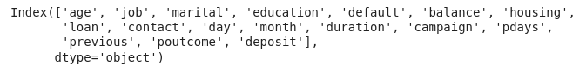

**Look up the types of the columns**

However, if we use **.info()**, we will obtain a list of the DataFrame columns together with additional information, such as the data type of each column and the count of non-null values.

# Display information about each column of the DataFrame  
df.info()

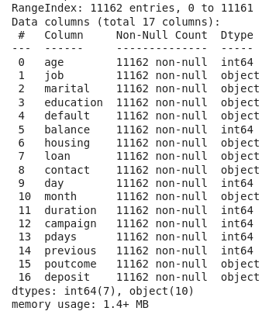

Now we know that we have **7 integer** columns and **10 columns** representing **categorical** data.

**Get the statistics of numerical columns**

Another useful method to get to know your data better is **.describe() .**This method returns the most important metrics for the distributions of the numerical variables, line the percentiles, the mean, the lowest and highest values, etc.

# Display the most important metrics of the numerical variables distributions  
df.describe()

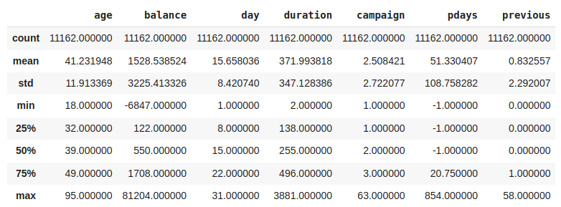

**Visualize the first rows of the DataFrame**

Another useful method when starting EDA is **.head()**, which allows you to display the first rows of a DataFrame.

# Displays the first 5 rows of the DataFrame  
df.head()

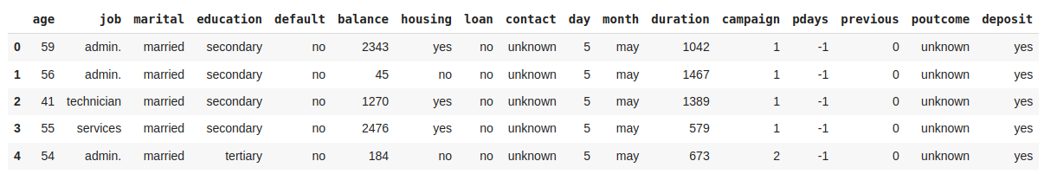

**Rename columns**

Most variable names are self-explanatory, but some lack of clear names to understand what they contain. Let's rename these variables to improve the analysis. The **inplace** parameter indicates that the changes will be made directly to the current DataFrame, **df**.

# Rename some columns to more understandable names  
df.rename(  
    columns={  
        'duration':'last_contact_duration',   
        'campaign': 'num_contacts',   
        'pdays': 'num_days_prev_campaign',   
        'previous': 'num_contacts_prev_campaign',   
        'poutcome': 'outcome_prev_campaign'  
        },   
    inplace=True)

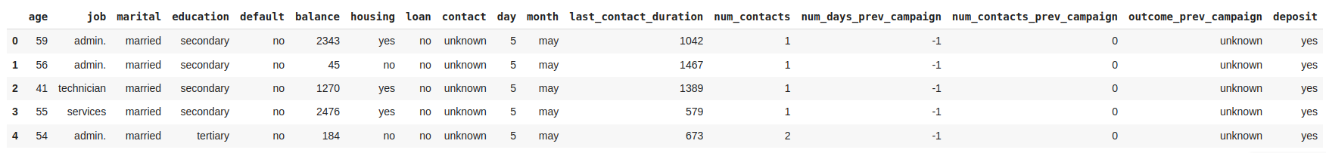

**Get advanced EDA report with pandas-profiling**

Use **pandas-profiling** to generate a report that includes the distributions of all variables, the number of missing values per variable, the summary of all data types and all the relevant correlations found among the variables of the dataset.

# Generate report for DataFrame "df"  
prof = ProfileReport(df)  
  
# Generate iframe of the report  
prof.to_notebook_iframe()

<https://s3-us-west-2.amazonaws.com/secure.notion-static.com/44c08f2f-cf85-499d-9751-cc473ae06993/pd_profile_report.html>  
https://s3-us-west-2.amazonaws.com/secure.notion-static.com/44c08f2f-cf85-499d-9751-cc473ae06993/pd_profile_report.html

**4. Prepare your data**

Data preparation, also known as **data preprocessing**, includes all **transformations** performed on the data before analysis, including **data cleaning** and **feature engineering**. This process is done following the next steps:

1. [Deal with Null values](https://www.graphext.com/c1be0fff112f4aefa09175b9977d9c13#16ce65864e4141629946f15000efa556)
2. [Deal with duplicates](https://www.graphext.com/c1be0fff112f4aefa09175b9977d9c13#700c15db6c0f41d3a9e3976dae153455)
3. [Deal with outliers](https://www.graphext.com/c1be0fff112f4aefa09175b9977d9c13#0718aa3095ca49239dbbb88bf8dbf2d8)
4. [Transform data](https://www.graphext.com/c1be0fff112f4aefa09175b9977d9c13#ec52dbe9ed0e41b1a40120e3b9c06a9c)

**Deal with Null values**

We can start preprocessing our data by looking for null values. When we find **null** or **NaN** values there are three approaches to deal with them:

1. Remove rows containing null values.
2. Drop columns with a high percentage of null values.
3. Fill null values with an arbitrary value, such as the mean of the variable's distribution.

# Drop rows containing missing values  
df.dropna(axis=0, inplace=True)  
  
# Drop columns containing missing values  
df.dropna(axis=1, inplace=True)  
  
# Fill missing values with the median  
df.fillna(df.mean())

Luckily, this dataset does not have any missing values in its columns. Therefore, there is no need to drop any rows. However, if we had encountered any NaN values, we could have used the **dropna** function as shown in the code above.

**Deal with duplicated samples**

Another common issue in data is the presence of **duplicated samples**. Usually, the data comes from traditional databases, and believe me it is not uncommon to encounter databases where the data is duplicated more than once or twice. Hence, it is important to check if our dataset has any duplicated samples and remove them if necessary using **drop_duplicates**.

# Displays the amount of duplicated samples in the DataFrame   
df.duplicated().sum()  
  
# Drop all duplicated samples but the first appearance  
df.drop_duplicates(keep="first", inplace=True)

**Deal with outliers**

**Outliers** are samples that deviate significantly from the rest of the data, and it is key to handle them to maintain the integrity of our EDA. One typical approach to detect outliers is by calculating the **Z-score** for each sample, which measures the number of standard deviations *std*  from the mean of the distribution to the . Observations with a **Z-score greater than 3** are typically considered outliers.

One way to deal with the outliers is to drop all the rows containing outliers, but depending the variable and the use case we can decide to stick with them.

# Create a list with the names of numerical columns  
numerical_columns = ["age", "balance", "day", "last_contact_duration", "num_contacts", "num_days_prev_campaign", "num_contacts_prev_campaign"]  
  
# Keep the samples that do not contain any outlier (all Z-scores below 3)  
df[(np.abs(scipy.stats.zscore(df[numerical_columns])) < 3).all(axis=1)]

**Transform data**

The Z-score assumes that the data follows a normal distribution to calculate the number of *std*away from the mean*.*Nonetheless, we often find distributions that are not following a normal distribution and are difficult to deal with. To address **outliers** originating from a **right-skewed distribution**, such as the *balance* variable, a possible solution is to apply a **log transformation** to normalize the distribution first.

# Create a new column with the log transformation of balance  
df["log_balance"] = df['balance'].transform(np.log)  
  
# Create a figure and axes  
fig, axes = plt.subplots(1, 2, figsize=(10, 5))  
  
# Plot the histograms of balance and log(balance)  
sns.histplot(df['balance'], bins=50, ax=axes[0]).set(xlabel="Frequency",ylabel="balance")  
sns.histplot(df['log_balance'], bins=50, ax=axes[1]).set(xlabel="Frequency",ylabel="log(balance)")  
  
# Add a titles to the charts  
fig.suptitle('Histograms of {} and {}'.format('balance', 'log(balance)'))  
  
# Adjust the spacing between subplots  
plt.tight_layout()  
  
# Show the plot  
plt.show()

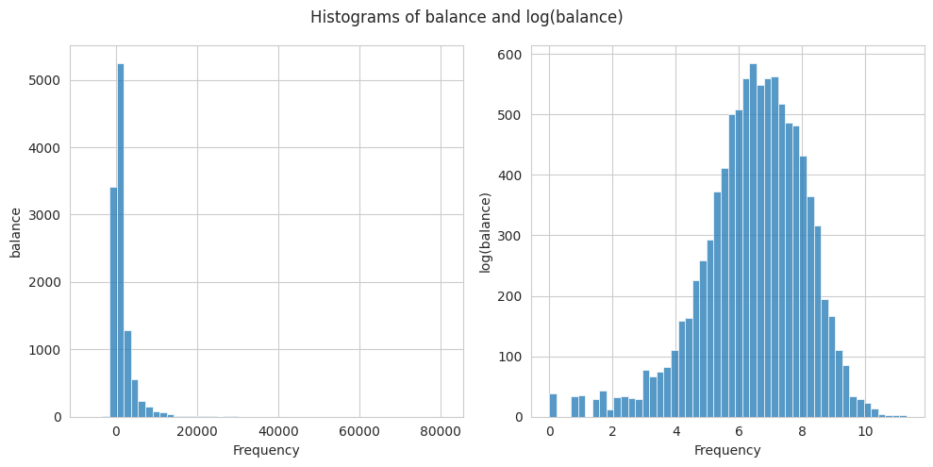

**5. Analyze your data**

Data analysis is key when building a model, and in general when we want to find **relationships** with respect to a **target variable**. However, even without a specific target, data analysis can be useful generating relationships among the variables. The main steps to perform the data analysis are:

1. [Analyze the distribution of the target variable](https://www.graphext.com/c1be0fff112f4aefa09175b9977d9c13#ebec642bfd0946f6b2a12b5bcfd45bab)
2. [Identify the variables relationships with the target variable](https://www.graphext.com/c1be0fff112f4aefa09175b9977d9c13#a0cc2f7333c34bb88b5eeef9187ae33c)
3. [Visualize the relationships with the target variable](https://www.graphext.com/c1be0fff112f4aefa09175b9977d9c13#f9aa58a15ded4370a81524372d7759dd)

**Distribution of the Target Variable**

The dataset we are exploring includes the target variable *deposit,* which the marketing department aims to optimize. This variable is a boolean indicating whether a customer opened a deposit after being contacted in the marketing campaign. Hence, the objective of the analysis is to identify the strongest relationships between customers who opened a deposit and the other variables.

As Data Scientists the first thing we want to know is the amount of customers that opened a deposit.

# Plot a bar chart with the count of customer opening and not opening a Deposit  
df["deposit"].value_counts().plot.bar()  
  
# Plot the values of each category on top of the bar  
plt.text(0, df["deposit"].value_counts()[0], str(df["deposit"].value_counts()[0]), ha='center', va='bottom')  
plt.text(1, df["deposit"].value_counts()[1], str(df["deposit"].value_counts()[1]), ha='center', va='bottom')  
  
# Set the labels and title  
plt.xlabel('Deposit')  
plt.ylabel('Count')  
plt.title('Counts of Customers that opened Deposit after contact')

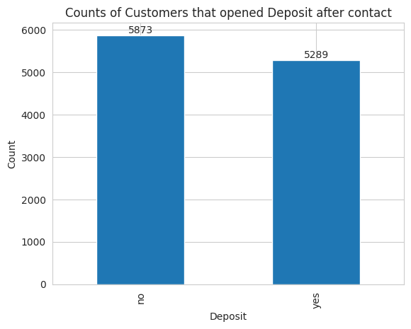

The dataset contains **5289** customers that **opened a deposit** after being contacted while the remaining **5873** **didn’t open the deposit**.

**Identify relationships with the target variable**

To quickly identify strong relationships with the target variable, we can plot the **correlation matrix**. However, since we have both categorical and numerical variables, the standard Pearson correlation coefficient, which only detects linear relationships among numerical variables, is not suitable. Instead, we can use **Cramer's V** coefficient to find relationships among the **categorical** variables of the dataset.

# Define a function that calcualtes Cramer's V coefficient among two variables  
def cramers_v(x, y):  
    confusion_matrix = pd.crosstab(x, y)  
    chi2 = scipy.stats.chi2_contingency(confusion_matrix)[0]  
    n = confusion_matrix.sum().sum()  
    phi2 = chi2 / n  
    r, k = confusion_matrix.shape  
    phi2corr = max(0, phi2 - ((k-1)*(r-1))/(n-1))  
    rcorr = r - ((r-1)**2)/(n-1)  
    kcorr = k - ((k-1)**2)/(n-1)  
    return np.sqrt(phi2corr / min((kcorr-1), (rcorr-1)))  
  
# Store in a list the names of the categorical variables  
categorical_variables = ['job', 'marital', 'education', 'default', 'housing', 'loan', 'contact', 'month', 'outcome_prev_campaign', 'deposit']  
  
# Factorize the categorical variables, i.e., convert the categories to discrete numbers  
df_factorized = df[categorical_variables].apply(lambda x: pd.factorize(x)[0])  
  
# Plot the correlation matrix in a heatmap  
sns.heatmap(round(df_factorized.corr(method=cramers_v), 2), annot=True, cmap='viridis')

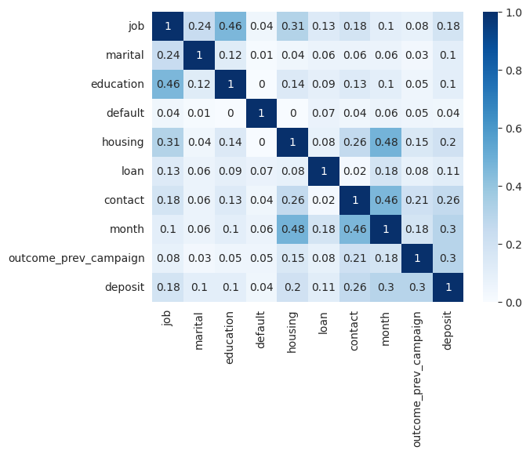

On the other hand, to learn how the **numerical** variables are correlated to the binary target we can use the **point biserial** correlation coefficient.

# Define a function that returns the point biserial r between a numerical and a categorical variable  
def pointbiserialr(x, y):  
  r, p_value = stats.pointbiserialr(x, y)  
  return r  
  
# Store in a list the names of the numerical variables  
numerical_columns = ["age", "balance", "day", "last_contact_duration", "num_contacts", "num_days_prev_campaign", "num_contacts_prev_campaign"]  
  
# Factorize the categorical target.   
df["deposit_fact"] = pd.factorize(df["deposit"])[0]  
  
# Create a DataFrame with the numerical variables and the factorized target  
df_biserial = pd.concat((df[numerical_columns], df["deposit_fact"]), axis=1)  
  
# Plot a heatmap with the point biserial r coefficients between the target and the numerical variables  
sns.heatmap(pd.DataFrame(df_biserial.corr(method=pointbiserialr)["deposit_fact"]), annot=True, cmap="cividis")

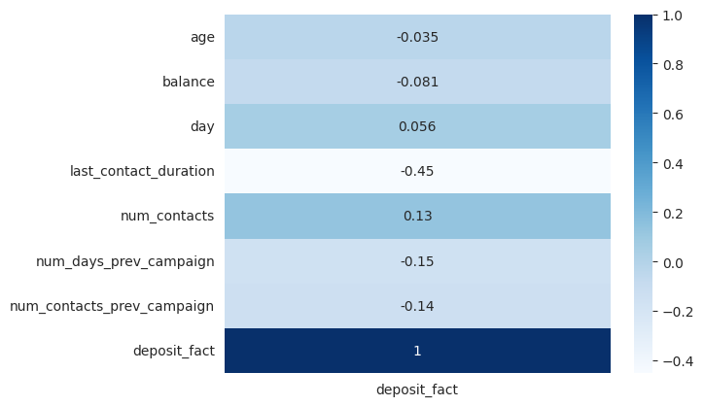

The correlation plots show that the target variable has no strong correlations with other variables but only moderate correlations. There is a correlation between the target variable ***deposit*** and ***last_contact_duration***. Additionally, there are moderate correlations between the target and variables such as ***contact***, ***month***, and ***outcome_prev_campaign***.

It is important to note that other methods, such as **Mutual Information**, are recommended for calculating correlations among all variables **regardless of their type**.

**Visualize relationships with target variable**

In the previous sections, we discovered the strongest relationships with the target variable. However, we don't know the nature of these relationships. The best way to understand them is through **data** **visualization**. Different types of variables require different types of plots for optimal visualization.

**Determine the relationship between a categorical and a numerical variable**

To understand the relationship between a **categorical** and a **numerical** variable, we should look at how the distribution of the numerical variable changes across different categories. Two effective visualizations for this purpose are **overlaid histograms** and **segmented boxplots**.

# Create a figure with two subplots  
fig, axs = plt.subplots(1, 2, figsize=(12, 5))  
  
# Plot the overlais histogram on the first subplot  
sns.histplot(data=df, x="last_contact_duration", hue="deposit", bins=50, element='poly', palette=["C2", "C3"], kde=True, ax=axs[0])  
axs[0].set_title('Histogram')  
  
# Plot the segmented boxplot on the second subplot  
sns.boxplot(data=df, x="deposit", y="last_contact_duration", palette=["C2", "C3"], saturation=1, orient="v", ax=axs[1])  
axs[1].set_title('Boxplot')  
  
# Adjust the spacing between subplots  
plt.tight_layout()  
  
# Show the plot  
plt.show()

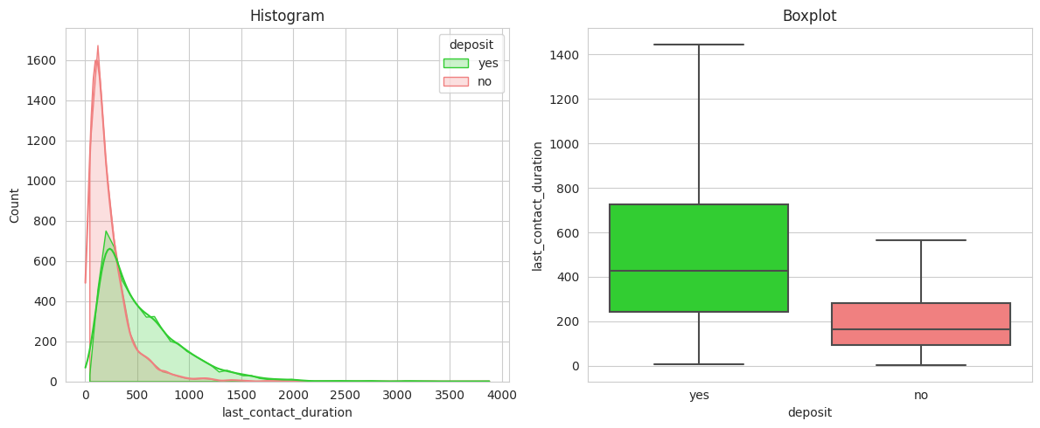

The **call duration** is significantly **longer** for customers who ended up **opening a deposit**. This validates the hypothesis that longer conversations have a higher probability of conversion.

**Determine the relationship between two categorical variables**

To visualize the relationship between **categorical** variables, **heatmaps** are a useful tool. Heatmaps display the count of samples for each combination of categories and show the relative distribution of all categories from one variable across each category of the other variable. In addition to heatmaps, we can use **clustermaps**, which are special type of heatmaps that order the categories to highlight the differences using hierarchical clustering.

# Create crosstab between the desired categories  
df_crosstab = pd.crosstab(df.job, df.deposit, normalize='index')  
# Create clustermap  
g = sns.clustermap(df_crosstab, annot=True, cmap='Blues', fmt=".2f", col_cluster=False, cbar=False, cbar_pos=None)  
# Add title  
g.fig.suptitle('Clustermap')  
# Plot figure  
plt.show()

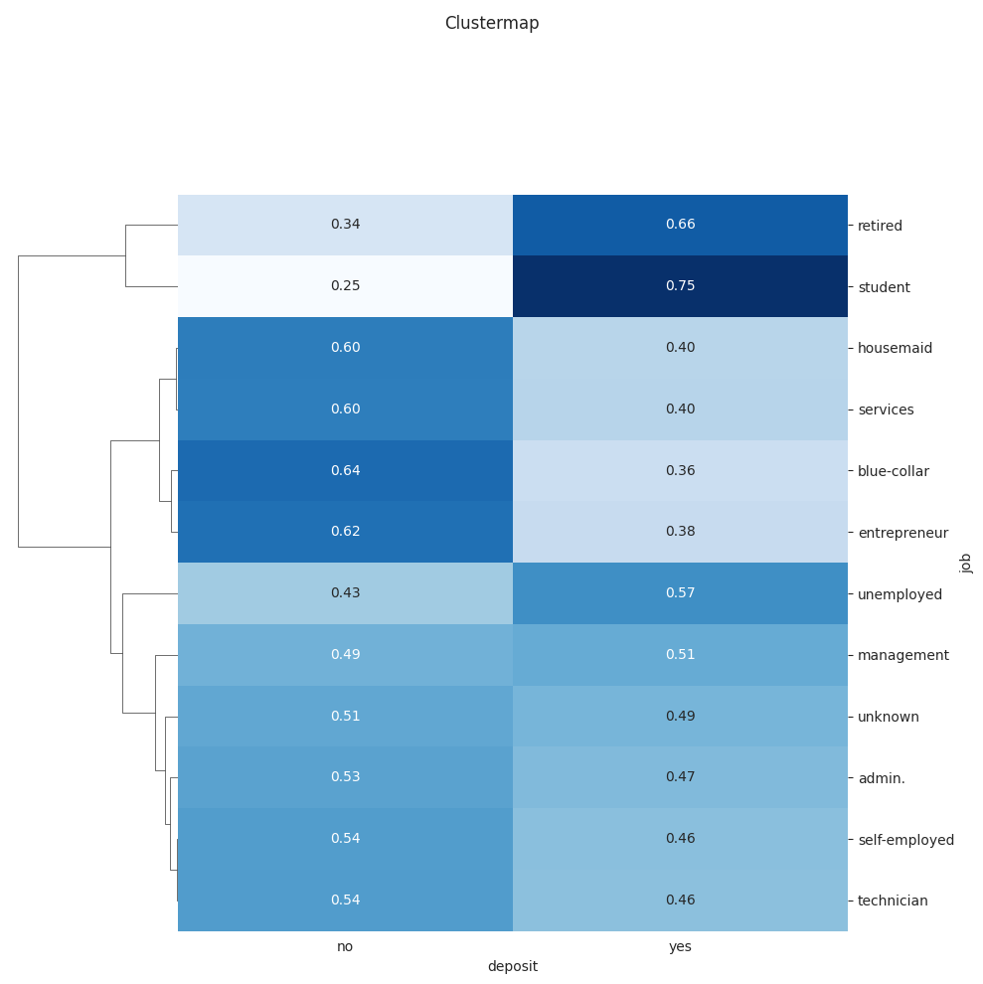

Additionally, **relative stacked bar charts** are effective for quickly visualizing the relative distribution, particularly when there are not many categories.

# Create stacked barchart  
df_crosstab.plot(kind="bar", stacked=True, width=0.7, color=['lightcoral', 'limegreen'], title="Stacked barchart")  
# Plot figure  
plt.show()

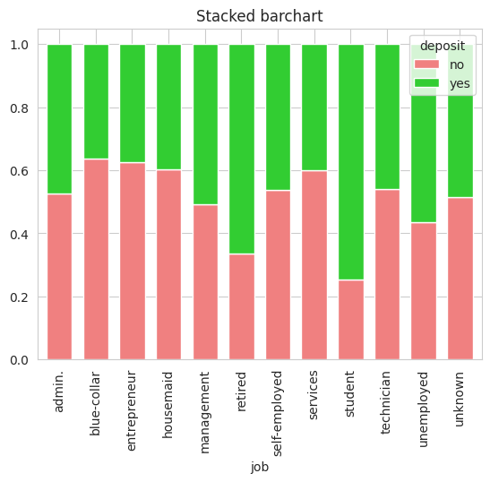

The charts show clear relationships between certain occupations of the contacted customers and conversion. **Students and retired** individuals have the **highest conversion rates** at **75%**and **66%**respectively. In contrast, **blue-collar workers** (manual workers) and **entrepreneurs** have the **lowest conversion** chances at **36%** and **38%**.

**Determine the relationship between two numerical variables**

The **scatterplot** is a popular way to visualize relationship between **numerical** variables. It offers the flexibility to incorporate a **3rd** and even a **4th** variable by using **color** and **size**. To show the amount of information scatterplots provide, we have plotted *age* on the X-axis, l*og(balance)* on the Y-axis (to lower the impact of outliers), *marital* status represented by color, and *last_contact_duration* indicated by the size of the data points.

df["log_balance"] = df['balance'].transform(np.log)  
ax = sns.scatterplot(data=df, x="age", y="log_balance", hue="marital", size="last_contact_duration", marker="$\circ$", sizes=(2, 150), legend="auto")  
  
plt.setp(ax.get_legend().get_texts(), fontsize='8') # for legend text  
  
plt.show()

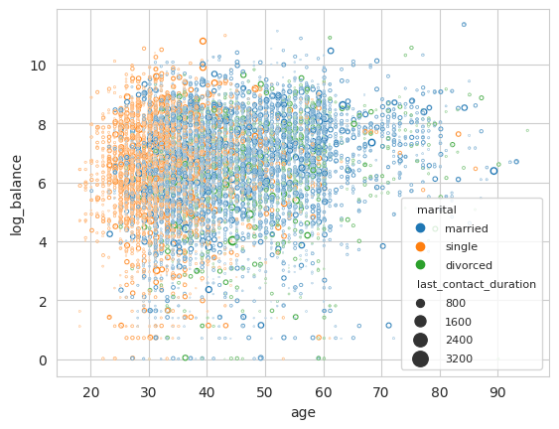

In the chart, one relevant pattern is that **single customers** are more **frequent** in the **20-40 age** range. Besides, the chart displays that it is **not very frequent** to find **older customers** (>60 years) with **low balances**.

**Top 3 challenges when using Python for EDA**

Exploratory Data Analysis, as any other field faces some challenges, which need to be considered to achieve accurate analysis and this is why we built Graphext. Some of the most important challenges to have in mind during EDA are:

1. **Data Volume and dimensionality:** Extracting insights from large and high-dimensional datasets with complex relations can be very challenging.
2. **Data Visualization:** Choosing the right visualization to effectively explore variable relations in a meaningful and informative way can be very difficult.
3. **Time and Resource Constraints:** Exploratory data analysis is time-consuming, and in many cases it is only the beginning of the work for a data scientists. Hence, making this process fast and simple would ease the life of data scientists.